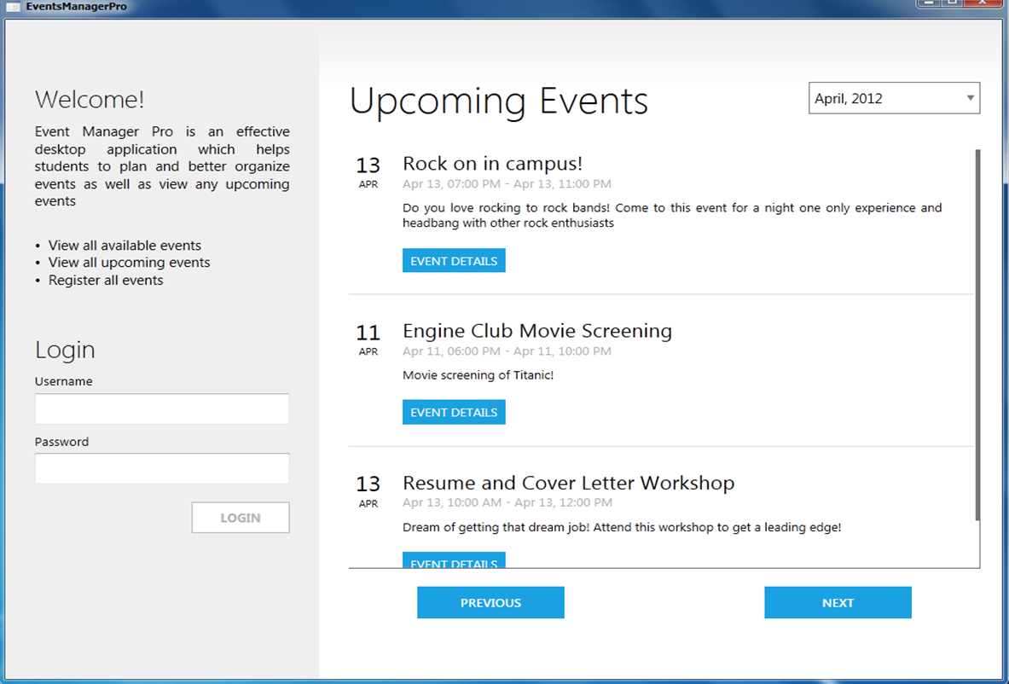 

NATIONAL UNIVERSITY OF SINGAPORE (NUS)

EVENT MANAGER PRO V0.2

**USER GUIDE**

Team Members (Group 44):

Melvin Lee Wei Ming A0087914U

Muhammad Hizam Bin Kamis U095858L

Tioh Wei Lun U096988R

Veeraya Pupatwibul A0069637N

* 1. **Introduction**
* This user guide describes V0.2 of Event Manager Pro
* For a quick walkthrough, please refer to the Frequently Asked Questions (FAQ) in Section 4

**1.2 What is Event Manager Pro?**

* Event Manager Pro is an effective desktop application which helps students to plan and better organize events as well as register for any upcoming events
* It has a graphical interface to make the application user-friendly for the user

**1.3 Target Users**

* Event Manager Pro caters specifically to tertiary students from NUS
* It is intended for general usage at a single computer kiosk at NUS Central Library
  1. **Useful Information**
* Any visitor can use the computer kiosk to access the application and view the list of upcoming events
* However, you can only create and manage an event if you logs in. The process for logging in will be described in Section 2.2.3

CONTENTS:

1. **Welcome**
2. **Login and Home Screen**
3. **Input and Edit Event**
4. **FAQ**

1. WELCOME

**V0.2 - APRIL 2012**



1. WELCOME - contd

**1.5 Overview of Functionality**

* View the list of upcoming events
* Log in using their Matriculation Number
* Create, edit or delete events
* Option to publish and advertise event at Front Page
* Register and deregister for the events
* View all events that a participant signed up for
* View and edit the guest list
* Edit event itinerary
* Use built in budget manager to plan expenses

**V0.2 - APRIL 2012**

CONTENTS:

1. **Welcome**
2. **Login and Home Screen**
3. **Input and Edit Event**
4. **FAQ**

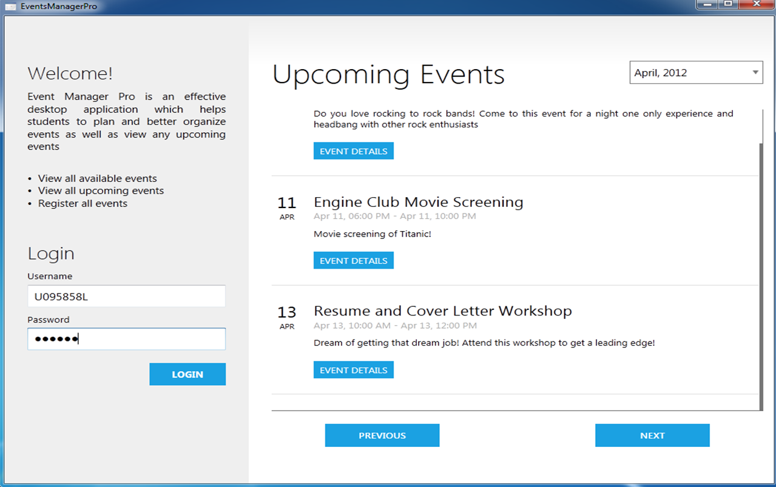

**Details Button:**

**View event details**

**Login:**

**Login here with the default account**

2. LOGIN & HOME SCREEN

**2.1 Getting Started**

* Double – click on the file titled “Event ManagerApp.exe”
* The application will load and a Login Screen should appear

**2.2 Login Screen**

You are able to do the following at the Login Screen:

**2.2.1 View List of Events**

- The details of upcoming events (i.e. name, time, date, venue, description) will be displayed here

- You can toggle the list by month by clicking on the “NEXT” and “PREVIOUS” button or using the drop down menu at the top right hand corner

**Note: You can only view upcoming events which are within 12 months ahead of the current date**

**Toggle Buttons:**

**Click these to toggle events by months**

**V0.2 - APRIL 2012**

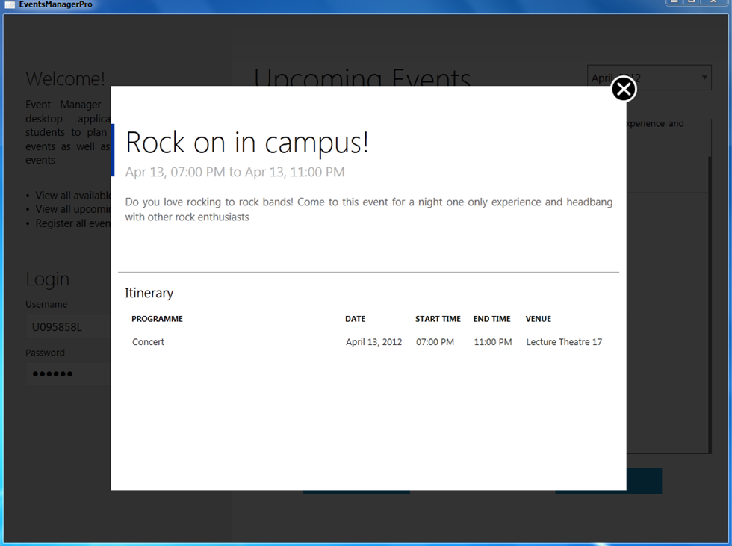

**Event Info Dialog:**

Show more details of an event

**V0.2 - APRIL 2012**

2. LOGIN & HOME SCREEN - contd

**2.2.2 View Event Details**

- You can get more information for a particular event by clicking on the blue “Event Details” button

- An event info dialog will then appear which will show more details for the event such as the itinerary and venue(s)

**2.2.3 Log In**

- You can login at the left hand corner by entering your username and password as provided by the administrator

- If the login is successful, you will be directed to the Home Page

**Note: Please ensure that you remember to log out after every session to protect the security of your account**



2. LOGIN & HOME SCREEN - contd

**2.3 Home Screen**

You will be signed in as the user. The list of features and functionality available at the Home Page is as follows:

**2.3.1 View List of Events**

- You can toggle between the “Upcoming” and “My Events” tab to view all the listed events as well as your created events

- You can also sort the events alphabetically and numerically by the clicking on the different header titles (i.e. Event Name, Date, Time and Venue)

2.3.1.1 Upcoming Tab

Here, you can view both your created events and other listed events

**Created Events** - There will be 3 buttons titled “INFO”, “EDIT” and “DELETE” under the Action(s) heading

**INFO Button** - Click on this gray button to view the event details

**EDIT Button** - Click on this blue button to edit the event details. You will be directed to the Edit Event Screen

**DELETE Button** - Click on this red button to delete your event

**Public Listed Events** - There will be 2 buttons titled “INFO” and “REGISTER / UNREGISTER”under the action(s) heading

**V0.2 - APRIL 2012**

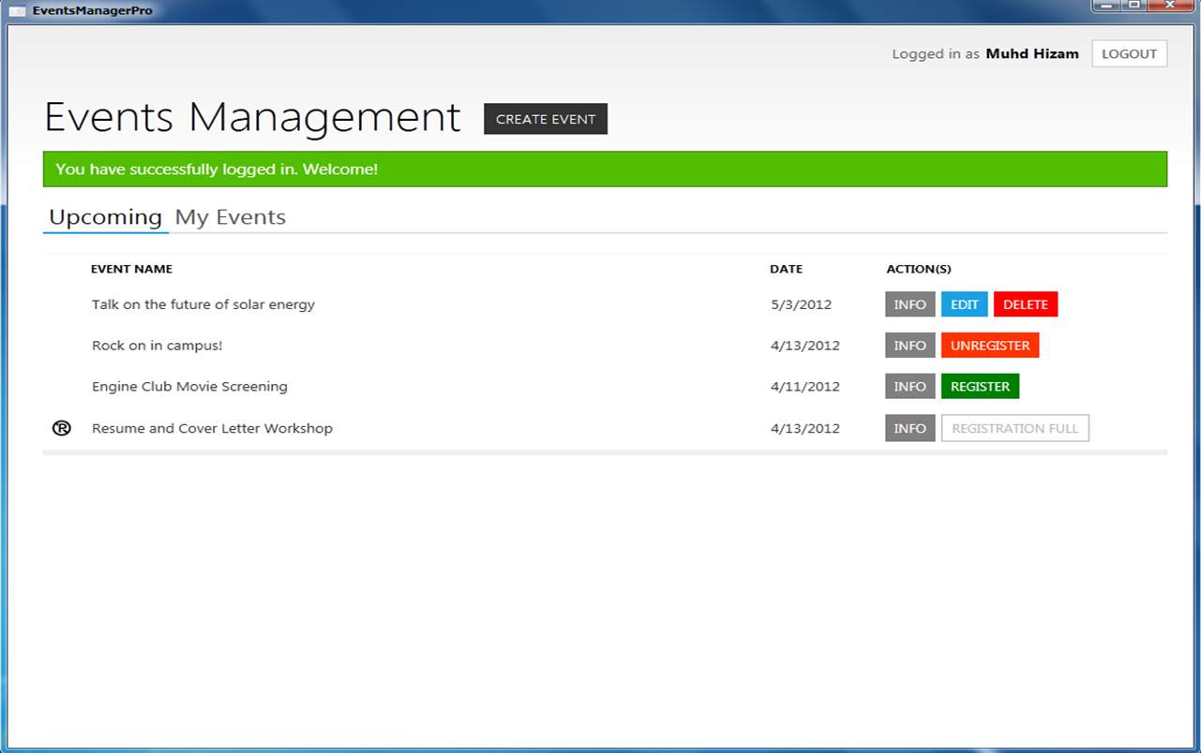

**P Icon:**

**This icon will appear if the registration is full for the event**

**Header Tabs:**

**Click on these tabs to view all upcoming events or your events**

**Action(s) Buttons:**

**Click these buttons to perform the action**

**Filter Events:**

**Click on the header titles to filter events**

2. LOGIN & HOME SCREEN - contd

**REGISTER / UNREGISTER Button** - Click on this button to register or deregister for an event

**Note: A P icon beside an event indicate that the registration is full. You will not be able to register for the event if you have not registered previously**

**V0.2 - APRIL 2012**



2. LOGIN & HOME SCREEN - contd

2.3.1.1 My Events Tab

Here, the events will be categorized into “CREATED EVENTS” and “REGISTERED EVENTS”

**CREATED Events** - There will be 2 buttons titled “EDIT” and “DELETE” under the Action(s) heading. You can again edit or delete any of your created events by clicking on these buttons.

**REGISTERED Events** – Here, you can view the events that you registered for. You may wish to unregister for any event by clicking on the “UNREGISTER” button

**Note:**

1. **A P icon beside your event indicate that the registration is full. You may consider increasing the event capacity.**
2. **A $ icon beside your event indicate that your expenditure have exceeded your budget. You may wish to remove some items or edit your budget**

**V0.2 - APRIL 2012**

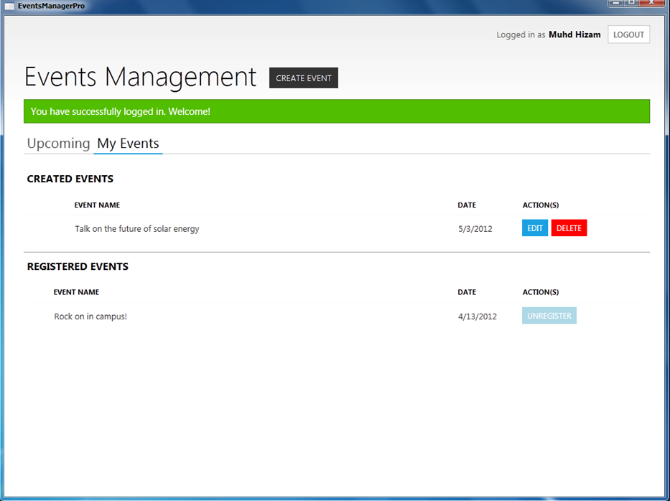

**Create Event Button:**

**Click on this create event**

**Logout Button**

**Registered Events**

**List of your registered events**

2. LOGIN & HOME SCREEN – contd

**2.3.2 Create Event**

- You can create an event by clicking on the “Create Event” button at the top. Upon clicking, you will be directed to the New Event Screen

**2.3.3 Log Out**

- You can log out of your account by clicking on the “Log Out” button at the top right hand corner

- You will then be redirected to the Login Screen

**V0.2 - APRIL 2012**



3. INPUT & EDIT EVENT

**3.1 New / Edit Event Screen**

Here, you are able to enter or edit the details of your event. You can go to this page by following the instructions from Section 2.3.1 or 2.3.2. The general guidelines for creating / editing an event are as follows:

**3.2 Enter Details of Events**

**Event Name** - Enter the event name at the textbox at the top

**Note: You will not be able to change your event name once it has been created**

3.2.1 General Tab

**Description** - Enter a brief description of your event to provide more information and details

**Capacity and Budget** - Enter the estimated capacity and budget at the respective textboxes

**Visible to Public?** - Check this box if you wish to make your event public and advertise the event at the Login Screen

**Note: You cannot edit the Capacity when your event’s start date is less than 3 days from the current date**

3.2.2 Itinerary Tab

**Programme** -Enter the programme name

**Date** - Either type or select the event date from the drop-down mini calendar (i.e. datepicker)

**V0.2 - APRIL 2012**

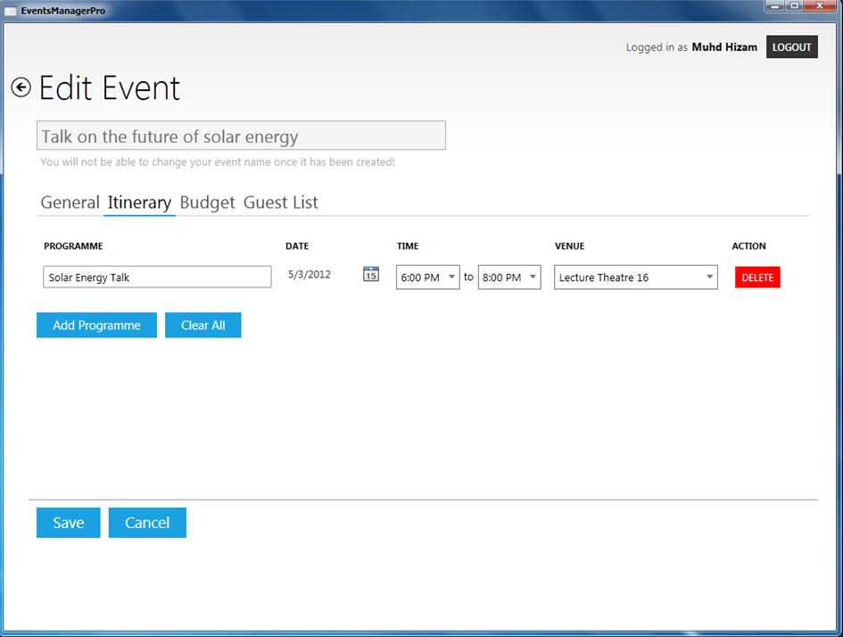

**Itinerary Tab:**

**Choose date, time and venue**

**Add Programme:**

Click this to add programme

3. INPUT & EDIT EVENT - contd

**Start Time and End Time** - Select the Start Time and End Time from the drop-down menu

**Venue** - Choose a venue from the available list at the drop-down menu

**Add Programme** - Click this blue button to add more programmes to the itinerary

**Clear** - Click this blue button to remove all programs from the itinerary

**Delete** - Click this red button to remove the selected programme from the itinerary

**Note: You cannot edit the Itinerary when your event’s start date is less than 3 days from the current date**

**V0.2 - APRIL 2012**

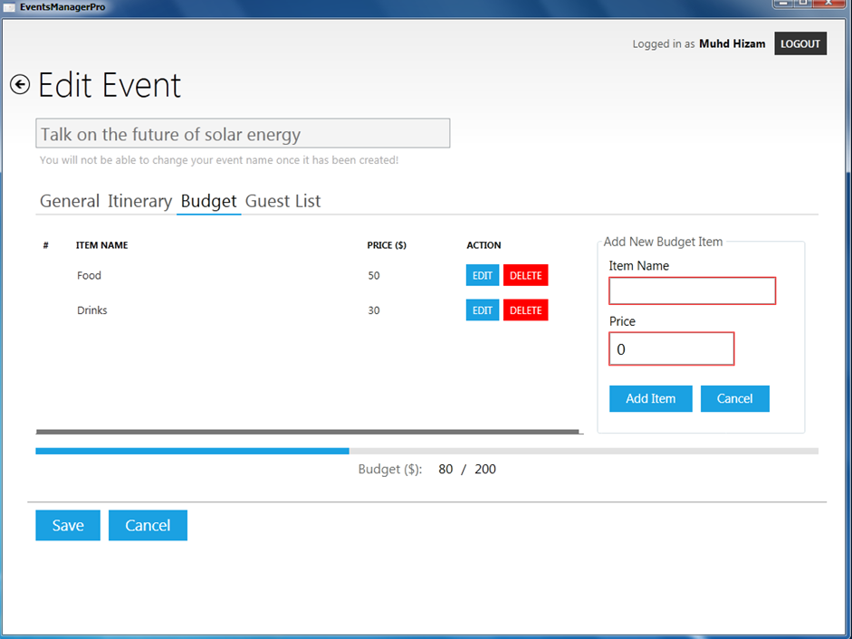

**Budget Tab:**

**Budget List:** This shows your current expenditure

**Dynamic Progress Bar**

**Add Item Button:** Click on this to add item into the shopping list

3. INPUT & EDIT EVENT - contd

3.2.3 Budget Tab

**Item Name and Price** - Enter the item name and price in dollars and click on the “Add Item” button to add the item into the budget list. You reset the fields by clicking on the “Cancel” button

**Budget List** – All your shopping items will be shown in this list. The dynamic progress bar at the bottom will visually show how close you are to reaching your budget

**Edit or Delete** – Click on these buttons to edit or delete the item details

**V0.2 - APRIL 2012**

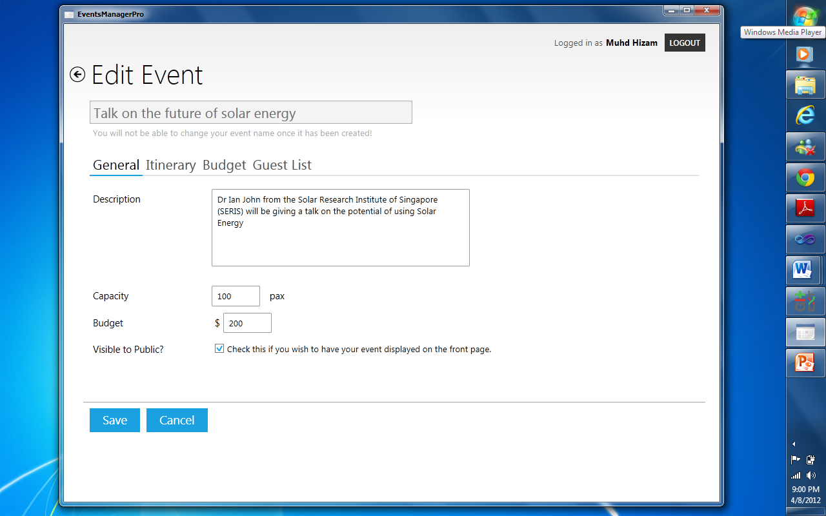

3. INPUT & EDIT EVENT DETAILS - contd

3.2.4 Guest List Tab

**Guest List** - You will able to see the details of those have registered for the event here

**Delete** - Click on this button to remove the selected guest from the guest list

**Note: This tab will not be available when you first create the event. You can view this tab through the Edit Event Screen**

**3.3 Save Event**

- Once you are done, you can click on the “Save” button at the bottom to

either create or save any changes to your event

**Note: If the “Save” button does not appear, hover over the highlighted red fields to determine cause**

**3.4 Cancel Event**

- You can cancel the event creation or cancel any event changes by clicking on the blue “Cancel” button

**Save / Cancel Button**

**V0.2 - APRIL 2012**



4. FREQUENTLY ASKED QUESTIONS (FAQ)

**4.1 How do I start and run the application?**

Double – click on the file titled “Event ManagerApp.exe” . The application will load and a Login Screen should appear.

**4.2 How do I login into the system?**

You can login into the system by using your Matric Id and password as provided by the administrator. Refer to Section 2.2.3 for more details.

**4.3 How do I view all the listed events?**

You can view all the listed events at the Login Screen or at the Home Screen by logging into your account.

**4.4 How do I register / unregister for an event?**

You will need to login to register / unregister for an event. At the Home Screen, click on the “Register / Unregister” button for the particular event. Refer to Section 2.3.1 for more details.

**4.5 How do I create an event?**

You will need to login to create an event. At the home screen, click on the “Create Event” button at the top. Refer to Section 3 for more details of entering the event details.

**V0.2 - APRIL 2012**



4. FREQUENTLY ASKED QUESTIONS (FAQ)

**4.6 How do I edit my event details?**

You will need to login to edit your event details. At the home screen, click on the blue “EDIT” button at your event under the ACTION(s) heading to edit your event details. Note that you can only edit your own event. The event title cannot be changed and some details such as the capacity and itinerary cannot be edited less than 3 days from the event date. Refer to Section 3 for more details

**4.7 How do I delete my event?**

You will need to login to delete. At the home screen, click on the red “DELETE” button at your event under the ACTION(s) heading to delete your event. Note that you can only delete your own event.

**4.8 How do I choose a venue for my event?**

You will need to login to choose a venue. You can choose your venue from the Itinerary Tab from the New / Edit Event Screen when you are creating a new or editing an event. Refer to Section 3.2.2 for more details.

**4.9 How do I view the guest list for my event?**

You will need to login to view the guest list. At the home screen, click on the blue “EDIT” button to go to the Edit Event Screen. Toggle to the “Guest List” tab to see the guest list. Refer to Section 3.2.4 for more details.

**V0.2 - APRIL 2012**